Url Shortner

Table of Contents

Important Links 1

API Information 1

Create Short Url (POST) 1

Get complete details based on Short URL (GET) 1

Get Long Url from Short URL (GET) 2

Redirect to Long Url from Short URL (GET) 2

Delete Record of Short URL (DELETE) 2

Azure DevOps 3

Build 3

Release 3

Azure Server 4

Monitoring 5

Database 5

# Important Links

|  |  |  |
| --- | --- | --- |
| S.No | Content | Link |
| 1. | Source Code | <https://github.com/gourav17/Url-Shortner> |
| 2. | API Deployed | [http://url-shortner-dev-as.azurewebsites.net](http://url-shortner-dev-as.azurewebsites.net/) |
| 3. | Application | <http://url-shortner-dev-as.azurewebsites.net/MyUrl/CreateShortUrl> |
| 4. | Example | <https://url-shortner-dev-as.azurewebsites.net/bqYlS> |
| 5. | Azure Deployment | <https://dev.azure.com/gourav17/> |
| 6. | Azure Portal | [https://portal.azure.com](https://portal.azure.com/) |

# API Information

url = [http://url-shortner-dev-as.azurewebsites.net](http://url-shortner-dev-as.azurewebsites.net/)

## Create Short Url (POST)

Create short url for a long url provided

**API :** http://{{url}}api/shortme?url={{longurl}}

**Example :**

http://{{url}}/api/shortme?url=https://www.amazon.in/Canon-EOS-200D-II-Digital/dp/B07RJWB548/ref=gbps_img_s-5_2299_b8ea221a?smid=A14CZOWI0VEHLG&pf_rd_p=f3aaeb13-62aa-445b-aeff-6ddd854a2299&pf_rd_s=slot-5&pf_rd_t=701&pf_rd_i=gb_main&pf_rd_m=A1VBAL9TL5WCBF&pf_rd_r=95V9CGVS7EHPKTGBC9PY

## Get complete details based on Short URL (GET)

Used to get complete record from ShortUrl

API : http://{{url}}/api/getlongurl?url={{shortUrl}}

**Example:**

http://{{url}}/api/getlongurl?url=bqYlS

## Get Long Url from Short URL (GET)

Used to get Long URL from ShortUrl

**API :** http://{{url}}/api/Url?shortUrl={{shortUrl}}

**Example:**

http://{{url}}/api/Url?shortUrl=bqYlS

## Redirect to Long Url from Short URL (GET)

Can redirect to long URl based on ShortUrl

**API :** http://{{url}}/api/redirecttolongurl?url={shorturl}

**Example:**

[http://{{url}}/api/redirecttolongurl?url=bqYlS](%20http://%7b%7burl%7d%7d/api/redirecttolongurl?url=bqYlS)

<http://url-shortner-dev-as.azurewebsites.net/api/redirecttolongurl?url=bqYlS>

## Delete Record of Short URL (DELETE)

Used to delete a short Url entry. Can be made to access by Authentication only in future.

**API :** http://{{url}}/api/removeurl?url={shorturl}

**Example:**

[http://{{url}}/api/removeurl?url=bqYlS](%20http://%7b%7burl%7d%7d/api/removeurl?url=bqYlS)1

# Azure DevOps

## Build

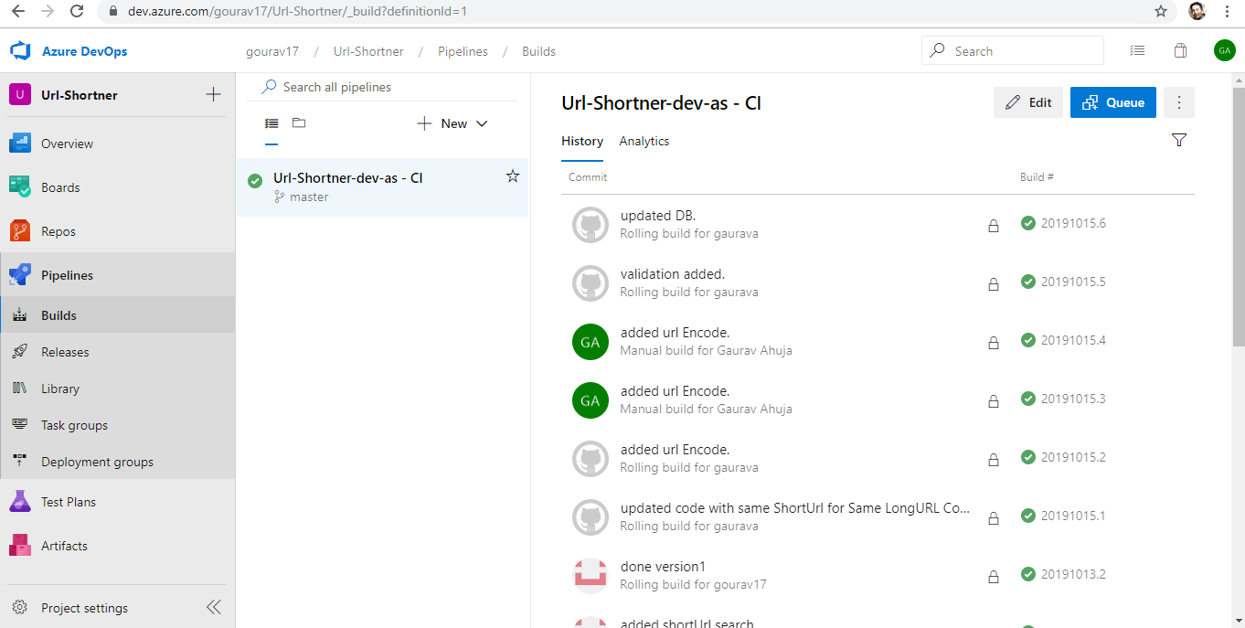

## Release

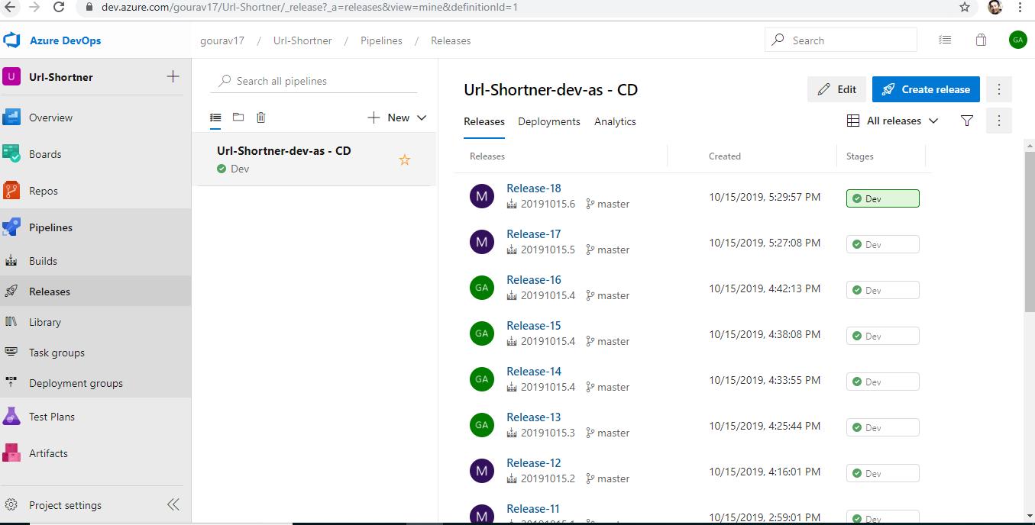

**Variable List**

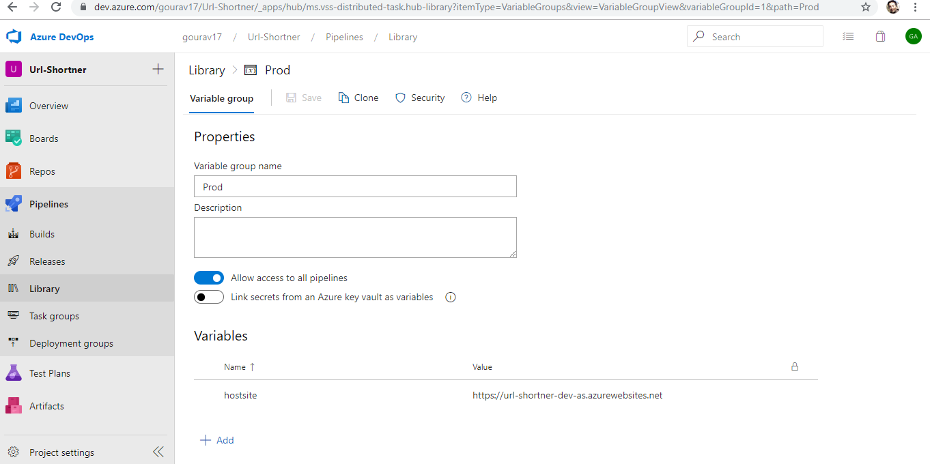

# Azure Server

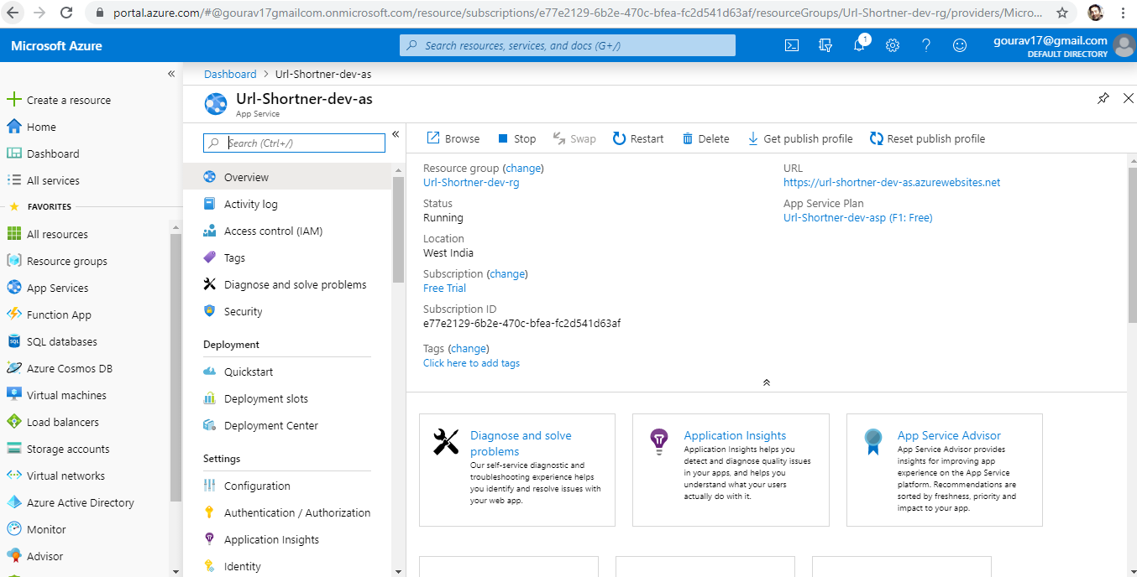

## Monitoring

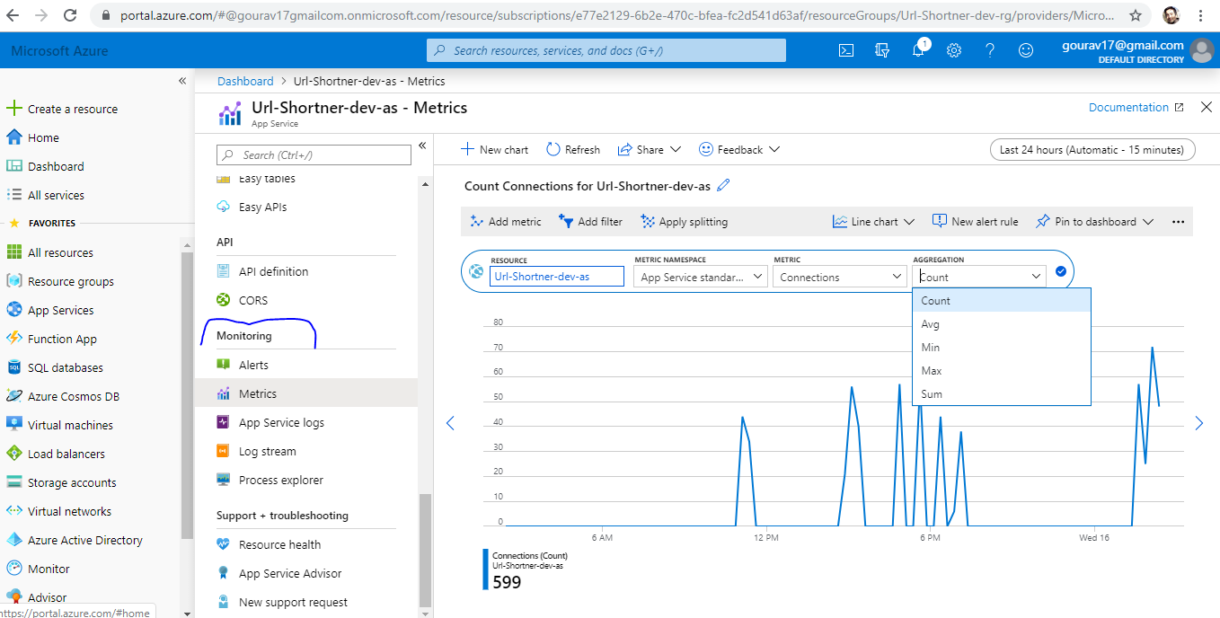

## Database

